**ECONOMIC SURVEY OF INDIA 2021-22**

**(SUMMARY)**

MADE BY-ASHUTOSH SINGH

2K20/EE/67

DELHI TECHNOLOGICAL UNIVERSITY

Recently, the Economic Survey **2021-22** was tabled in **Parliament** by the Finance Minister soon after the President's address to both Houses of Parliament.

The central theme of this year’s Economic Survey is the **“Agile approach”.**

This year's survey uses various examples to highlight the **use of satellite and geospatial data**

to reflect the infrastructural growth in the country.

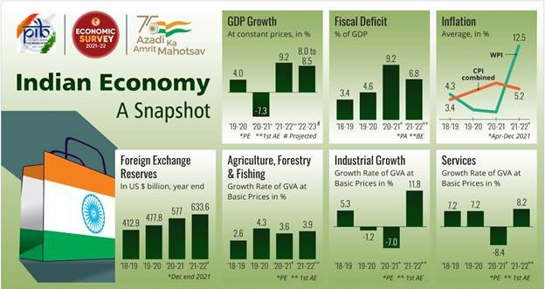

### What is Economic Survey?

### It is prepared by the Economics Division of the Department of Economic Affairs (DEA)

under the guidance of the Chief Economic Advisor.

It is usually presented a day before the Union **Budget** is presented in the **Parliament.**

The **first Economic Survey in India was presented in the year 1950-51.** Up to 1964, it was presented along with the Union Budget. From 1964 onwards, it has been delinked from the Budget.

## What are the Key Points of the Economic Survey 2021-22?

### State of the Economy (GDP Growth):

The Indian economy is **estimated to grow by 9.2% in real terms in 2021-22** (as per

**first advance estimates**) subsequent to **a contraction of 7.3% in 2020-21**.

### The Gross Domestic Product (GDP) projected to grow by 8-8.5% in real terms in 2022-23.

Projection comparable with **World Bank** and **Asian Development Bank’**s latest forecasts of real GDP growth of 8.7% and 7.5% respectively for 2022-23.

According to the **International Monetary Fund’s latest World Economic Outlook** projections, India’s real GDP is projected to grow at 9% in 2021-22 and 2022-23 and at 7.1% in 2023-2024, which would **make India the fastest growing major economy in the world for all 3 years.**

Combination of **high** Foreign Exchange Reserves, **sustained** Foreign Direct Investment**,** and **rising export earnings** will provide an adequate buffer against possible **global liquidity tapering** in 2022-23.

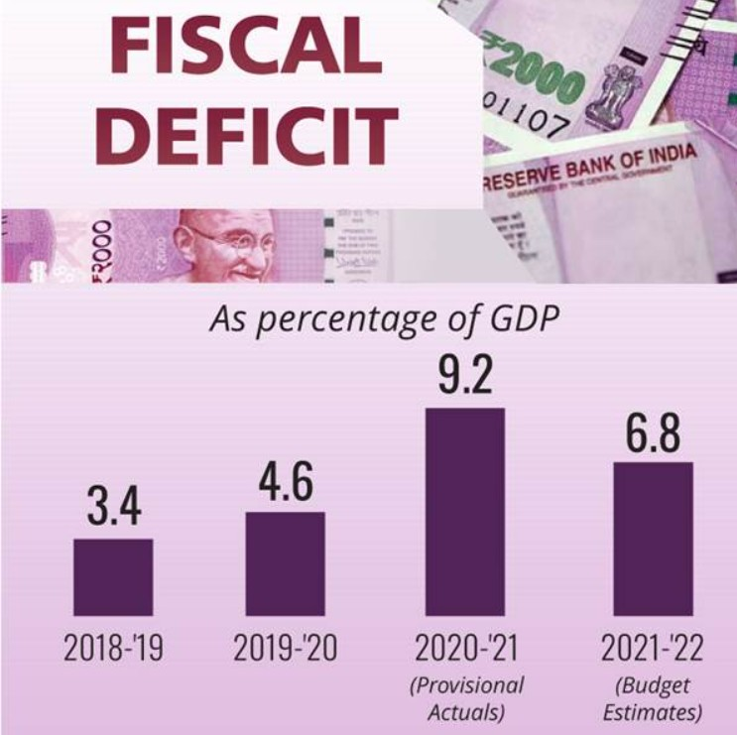**Tapering** is the theoretical reversal of quantitative easing (QE) policies, which are implemented by a central bank and intended to stimulate economic growth.

### Fiscal Developments:

**Sustained revenue collection and a targeted expenditure** policy has **contained the**

Fiscal Deficit for April to November, 2021 at 46.2% of Budget Estimates.

### The revenue receipts from the Central Government (April to November, 2021)

**have gone up by 67.2%** YoY(Year on Year) as against an expected growth of 9.6% in the

**2021-22 Budget** Estimates.

**Gross Tax Revenue** registers a **growth of over 50%** during April to November, 2021 in YoY terms.

This performance is strong compared to **pre-**pandemic **levels of 2019-2020 also. Tax Revenue** forms part of the Receipt Budget, which in turn is a part of the Annual Financial Statement of the Union Budget.

During April-November 2021, Capex (Capital Expenditure) has grown by 13.5% (YoY) with focus on **infrastructure-intensive sectors.**

With the **enhanced borrowings on account of** Covid-19, the Central Government debt has gone up from 49.1% of GDP in 2019-20 to 59.3% of GDP in 2020-21, but is expected to follow a **declining trajectory with the recovery of the economy.**

**Buoyant tax revenues and government policies** have created “headroom for taking up additional fiscal policy interventions”.

Stressing the need to continue the focus on capital expenditure, **it has indicated that the government is on course to achieve the fiscal deficit target of 6.8% of GDP for the current year (2021-22).**

### External Sectors:

India’s **merchandise exports and imports rebounded strongly** and surpassed pre- Covid levels during the current financial year.

### There was significant pickup in net services with both receipts and payments

crossing the pre-pandemic levels, despite **weak tourism revenues.**

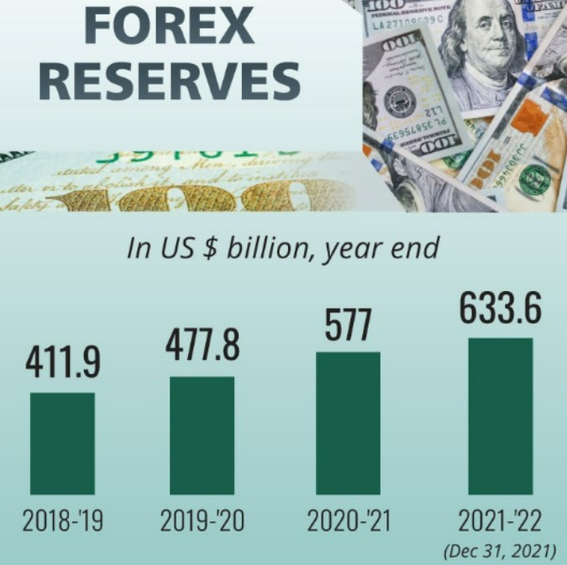**Net capital flows** were higher at USD 65.6 billion in the first half of 2021-22, on account of continued inflow of foreign investment, **revival in net** external commercial borrowings, higher banking capital and additional **Special Drawing Rights (SDR)** allocation.

As of end-November 2021, **India was the fourth largest forex reserves holder in the world** after China, Japan and Switzerland.

### Monetary Management and Financial Intermediation:

The **liquidity** in the system remained in surplus.

Repo rate **was maintained at 4%** in 2021-22.

**Reserve Bank of India** undertook various measures such as **G-Sec Acquisition Programme** and **Special Long-Term Repo Operations** to provide further liquidity.

The economic shock of the pandemic has been **weathered well by the commercial banking system:**

**Bank credit growth** accelerated gradually in 2021-22 from 5.3% in April 2021 to 9.2% as on 31st December 2021.

The **Gross Non-Performing Advances** ratio of **Scheduled Commercial Banks (SCBs)** declined from 11.2% at the end of 2017-18 to 6.9% at the end of September, 2021.

**Net Non-Performing Advances** ratio declined from 6% to 2.2% during the same period.

**Capital to risk-weighted asset ratio** of SCBs continued to increase from 13% in 2013-14 to 16.54% at the end of September 2021.

The **Return on Assets and Return on Equity for Public Sector Banks continued to be positive** for the period ending September 2021.

### Exceptional year for the capital markets:

Rs. 89,066 crore was raised via 75 **Initial Public Offering (IPO)** issues in April- November 2021, which is much higher than in any year in the last decade.

### Prices and Inflation:

The average **headline Consumer Price Index (CPI) -Combined inflation** moderated to 5.2% in 2021-22 (April-December) from 6.6% in the corresponding period of 2020-21.

The decline in retail inflation (CPI) was led **by easing** food inflation. Food inflation averaged at a low of 2.9% in 2021-22 (April to December) as against 9.1% in the corresponding period last year.

### Effective supply-side management kept prices of most essential commodities under control during the year. Proactive measures were taken to contain the price rise in pulses and edible oils.

**Reduction** in **central excise** and subsequent cuts in **Value Added Tax** by most States helped ease petrol and diesel prices.

**Wholesale inflation based on** Wholesale Price Index (WPI) rose to 12.5% during 2021-22 (April to December). This has been attributed to:

Low base in the previous year, Pick-up in economic activity,

Sharp increase in international prices of crude oil and other imported inputs, and High freight costs.

**Divergence between CPI-C and WPI Inflation:** The divergence peaked to 9.6% points in May 2020. However in 2021 there was a **reversal in divergence with retail inflation falling below wholesale inflation by 8.0% points** in December 2021. This divergence can be explained by factors such as:

Variations due to base effect,

Difference in scope and coverage of the two indices, Price collections,

Items covered,

Difference in commodity weights, and

WPI being more sensitive to cost-push inflation led by imported inputs.

With the gradual waning of base effect in WPI, the divergence in CPI-C and WPI is also expected to narrow down.

### Sustainable Development and Climate Change:

India’s overall score on the **NITI Aayog Sustainable Development Goals (**SDG**) India Index and Dashboard improved to 66** in 2020-21 from 60 in 2019-20 and 57 in

2018-19.

**India has the tenth largest forest area in the world**. In 2020, India ranked third globally in increasing its forest area during 2010 to 2020.

In 2020, the forests covered 24% of India’s total geographical area, accounting for 2% of the world’s total forest area.

In August 2021, the **Plastic Waste Management Amendment Rules, 2021**, was notified which is aimed at phasing out single use plastic by 2022.

Draft regulation on **Extended Producer Responsibility** for plastic packaging was notified.

The **Compliance status of Grossly Polluting Industries (GPIs)** located in the Ganga main stem and its tributaries improved from 39% in 2017 to 81% in 2020.

The Prime Minister, as a part of the national statement delivered at the **26th Conference of Parties (COP 26)** in Glasgow in November 2021, announced **ambitious targets to be achieved by 2030** to enable further reduction in emissions.

The need to start the one-word movement **‘LIFE’ (Lifestyle for Environment)** urging mindful and deliberate utilisation instead of mindless and destructive consumption was underlined.

### Agriculture and Food Management:

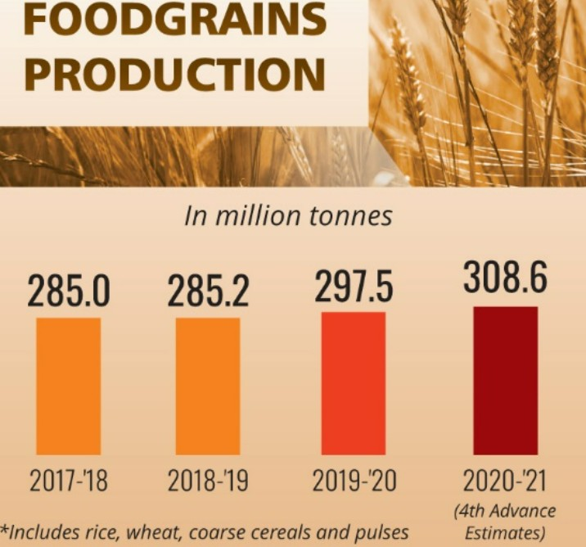

The Agriculture sector **experienced buoyant growth in the past two years,** accounting for a sizable 18.8% (2021-22) in Gross Value Added (GVA) of the country registering a growth of 3.6% in 2020-21 and 3.9% in 2021-22.

**Minimum Support Price (MSP) policy** is being used to promote **crop diversification.** Net receipts from crop production have increased by 22.6% in the latest **Situation Assessment Survey (SAS)** compared to the SAS Report of 2014.

**Allied sectors** including animal husbandry, dairying and fisheries are **steadily emerging to be high growth sectors** and major drivers of overall growth in the agriculture sector.

The Livestock sector **has grown at a CAGR of 8.15% over the last five years ending 2019-20.**

Government **facilitates food processing through various measures** of infrastructure development, subsidised transportation and support for formalisation of micro food enterprises.

India runs one of the **largest food management programmes in the world.** Government has further **extended the coverage of the food security network** through schemes like **PM Gareeb Kalyan Yojana (PMGKY).**

### Industry and Infrastructure:

The **Index of Industrial Production (IIP)** grew at 17.4% during April-November 2021 as compared to (-)15.3% in April-November 2020.

**Capital expenditure for the Indian railways has increased** to Rs. 155,181 crores in 2020-21 from an average annual of Rs. 45,980 crores during 2009-14 and it has been budgeted to further increase to Rs. 215,058 crores in 2021-22 – a five times increase in comparison to the 2014 level.

Extent of **road construction per day increased substantially** in 2020-21 to 36.5 Kms per day from 28 Kms per day in 2019-20 – a rise of 30.4%.

**Net profit to sales ratio of large corporations reached an all-time high** of 10.6% in July-September quarter of 2021-22 despite the pandemic (RBI Study).

Introduction of **Production Linked Incentive (PLI) scheme,** major boost provided to infrastructure-both physical as well as digital, along with measures to reduce transaction costs and improve ease of doing business, would support the pace of recovery.

### Services:

**Gross Value Added:**

GVA of services crossed pre-pandemic level in July-September quarter of 2021-22; however, **GVA of contact intensive sectors like trade, transport, etc. still remain below pre-pandemic level.**

Overall service Sector GVA is expected to grow by 8.2% in 2021-22.

### Foreign Direct Invest:

During the **first half of 2021-22, the service sector received over USD 16.7** billion Foreign Direct Invest – accounting for almost 54% of total FDI inflows into India.

### Reforms:

Major **government reforms include**, removing telecom regulations in IT-BPO sector and opening up of the space sector to private players.

### Exports:

Services exports surpassed pre-pandemic level in January-March quarter of 2020-21 and **grew by 21.6% in the first half of 2021-22** - strengthened by global demand for software and IT services exports.

### Start-Ups:

India has become the **3rd largest** start-up ecosystem **in the world** after the US and China. Number of new recognized start-ups increased to over 14000 in 2021-22 from 733 in 2016-17.

**44 Indian start-ups have achieved unicorn status in 2021** taking the overall tally of unicorns to 83, most of which are in the services sector.

### Social Infrastructure and Employment: Employment:

With revival of the economy, **employment indicators bounced back to pre- pandemic levels** during the last quarter of 2020-21.

As per the quarterly **Periodic Labour Force Survey (PFLS)** data up to March 2021, employment in urban sector affected by pandemic has recovered almost to the pre-pandemic level.

According to **Employees Provident Fund Organisation (EPFO)** data, formalisation of jobs continued during the second Covid wave; adverse impact of Covid on formalisation of jobs much lower than during the first Covid wave.

### Social Infrastructure:

**Expenditure on social services** (health, education and others) by Centre and States as a proportion of GDP increased from 6.2% in 2014-15 to 8.6% in 2021-22 (BE)

As per the **National Family Health Survey-5:**

**Total Fertility Rate (TFR)** came down to 2 in 2019-21 from 2.2 in 2015-16.

**Infant Mortality Rate (IMR)**, under-five mortality rate and institutional births have improved in 2019-21 over year 2015-16.

Under **Jal Jeevan Mission (JJM)**, 83 districts have become **‘Har Ghar Jal’** districts. Increased allotment of funds to **Mahatma Gandhi National Rural Employment Guarantee Scheme (MNREGS)** to provide buffer for unorganised labour in rural areas during the pandemic.

In addition to the **National Health Mission,** Union Budget 2021-22, announced **Ayushman Bharat Health Infrastructure Mission,** a new **Centrally Sponsored Scheme** to develop capacities of primary, secondary and tertiary Health Care Systems, strengthen existing national institutions, and create new institutions to cater to detection and cure of new and emerging diseases.

India is **among the few countries producing Covid vaccines.** The country started with two made in India Covid vaccines. In line with India’s vision of **Atmanirbhar Bharat**, India’s **first domestic Covid -19 vaccine, Whole Virion Inactivated Coronavirus Vaccine (**COVAXIN**)**, was developed and manufactured by Bharat Biotech International Limited in collaboration with National Institute of Virology of Indian Council of Medical Research (ICMR).

The **progress of vaccination should be seen not just as a health response indicator, but also as a buffer against economic disruptions** caused by repeated pandemic waves.

[**Source: PIB**](https://pib.gov.in/PressReleasePage.aspx?PRID=1793829)

# Economic Survey 2022: Concerns & Suggestions

## What are the Key Challenges highlighted by Economic Survey 2022?

### Increased Inflation:

The Survey notes that **supply chain disruptions and slow economic growth have contributed to an increase in inflation**. The withdrawal of stimulus in developed economies in the upcoming fiscal (2022-23) is likely to affect capital flows into the country. The **surge in energy, food, non-food commodities, and input prices, supply constraints, disruption of global supply chains, and rising freight costs** across the globe stoked global inflation during the year (2021-22).

Stimulus spending in developed economies and pent up demand during the pandemic could lead to **“imported inflation”** (Inflation due to increases in the prices of import) in India.

### Volatility in Capital:

The economic survey noted that **major economies had begun the process of withdrawing liquidity that was extended during the pandemic** in the form of stimulus checks and relaxed monetary policy to stimulate an economic recovery. Higher inflation has led to a winding down of pandemic related stimulus.

The likely withdrawal of liquidity by major central banks over the next year may also make **global capital flows more volatile,”** the survey said, noting that this may adversely affect capital flows, putting pressure on India’s exchange rate and slow economic growth. **India’s large and rising imports are also likely to put pressure on India’s exchange rate** if capital flows to India decrease as a result of a withdrawal of stimulus in developed countries.

### Employment:

A **lack of jobs also continues to be among the primary concerns** for the Indian economy with unemployment levels and labour force participation rates remaining worse than pre-pandemic levels.

According to data from the **PLFS,** while the **unemployment rate and labour force participation rate have improved somewhat** from the start of the pandemic, **they have still not recovered to pre-pandemic levels.**

## What are the Major Suggestions?

The Survey **calls for emphasis on developing a supply-side strategy** to deal with the long- term unpredictability of the post-Covid world, emanating mainly from factors such as changes in consumer behaviour, technological developments, geopolitics, climate change, and their potentially unpredictable interactions.

It calls for a **“diversified mix of sources of energy of which fossil fuels are an important part”,** but simultaneously calls for focus on building storage for intermittent electricity generation from solar PV and wind farms to ensure on-demand energy supply.

### It asks the government to focus on the pace of the shift from conventional fossil

**fuel-based sources,** and encourage R&D to ensure an effortless switch to renewable sources of energy.

It also has **called for a standardised framework for Cross-Border insolvency** as the **Insolvency & Bankruptcy Code (IBC)** at present does not have a standard instrument to restructure the firms involving cross border jurisdictions leading to several issues.

It **proposes use of the Agile approach to policy making with 80 high-frequency indicators** in an environment of “extreme uncertainty”.

The approach, used in project management and technology development, **assesses outcomes in short iterations while constantly making incremental adjustments.** The suggestion is based on the availability of a “wealth of real-time data” to take feedback- based decisions.

[**Source: PIB**](https://pib.gov.in/PressReleasePage.aspx?PRID=1793829)

# Reverse Repo Normalisation

## Why in News?

In a recent report, State Bank of India has stated that it believes the stage is set for a **Reverse Repo Normalisation** in India.

The Repurchase agreement (Repo) and the Reverse repo agreement are two key tools used by the

**Reserve Bank of India (RBI)** to control the money supply.

The tools used by the Central bank to control money supply can be **quantitative or qualitative.**

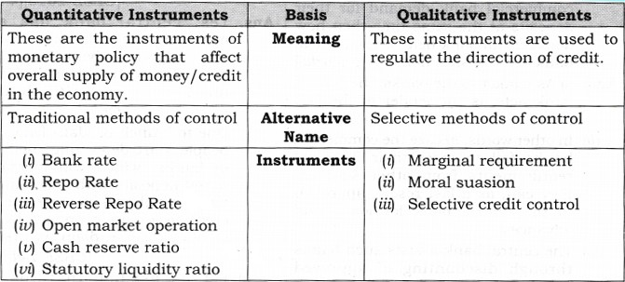

## What are Repo and Reverse Repo Rates?

### About:

Repo rate is the **rate at which the central bank of a country** (RBI in case of India)

**lends money to commercial banks** in the event of any shortfall of funds. Here, the central bank purchases the security.

The reverse repo **is the interest rate that the RBI pays to the commercial banks when they park their excess “liquidity” (money) with the RBI**. The reverse repo, thus, is the exact **opposite of the repo rate.**

### Significance:

**Under normal circumstances**, that is when the economy is growing at a healthy pace**, the repo rate becomes the benchmark interest rate in the economy.**

That’s because it is the **lowest rate of interest at which funds can be borrowed**. As such, the repo rate forms the floor interest rate for all other interest rates in the economy - be it the rate for a car loan or a home loan or the interest earned on fixed deposit etc.

When the **RBI pumps more and more liquidity into the market but there are no takers of fresh loans** — either because the banks are unwilling to lend or because there is no genuine demand for new loans in the economy.

In such a scenario, **the action shifts from repo rate to reverse repo rate** because banks are no longer interested in borrowing money from the RBI.

Rather they are more interested in parking their excess liquidity with the RBI. And that is how **the reverse repo becomes the actual benchmark interest rate in the economy.**

## What is Reverse Repo Normalisation?

### About:

It means the reverse repo rates **will go up** i.e. raising the reverse repo rate in one or two stages.

In the face of rising **inflation**, several central banks across the world have either increased interest rates or signalled that they would do so soon.

In India, too, **it is expected that the RBI will raise the repo rate.** But before that, it is **expected that the RBI will raise the reverse repo rate** and reduce the gap between the two rates.

### Significance:

The process of normalisation is mainly **aimed at curbing inflation.**

However, it will not only **reduce excess liquidity but also result in higher interest rates** across the board in the Indian economy.

Thus **reducing the demand for money among consumers** (since it would make more sense to just keep the money in the bank) and making it costlier for businesses to borrow fresh loans.

## What is Monetary Policy Normalisation?

The RBI keeps changing the total amount of money in the economy to ensure smooth functioning. As such, when the RBI wants to boost economic activity it adopts a so-called **“loose monetary policy”.**

There are two parts to such a policy:

**Injecting Liquidity in the Economy:** It does so by buying government **bonds** from the market. As the RBI buys these bonds, it pays back money to the bondholders, thus injecting more money into the economy.

**Lowering Interest Rate**: Two, the RBI also lowers the interest rate it charges banks when it lends money to them; this rate is called the **repo rate.**

By lowering the interest rate at which it lends money to commercial banks, the RBI hopes that the commercial banks (and the rest of the banking system), in turn, will feel incentivised to lower interest rates.

Lower interest rates and more liquidity, together, are expected to boost both consumption and production in the economy.

**For a consumer,** it would now pay less to keep the money in the bank — thus it incentivises current consumption. **For firms and entrepreneurs**, it would make more sense to borrow money to start a new enterprise because interest rates are lower.

The reverse of a loose monetary policy is a **“tight monetary policy”** and it **involves the RBI**

**raising interest rates** and sucking liquidity out of the economy by selling bonds (and taking money out of the system).

When any central bank finds that a loose monetary policy has started becoming counterproductive (for example, when it leads to a higher inflation rate), **the central bank “normalises the policy” by tightening the monetary policy stance.**

[**Source: IE**](https://indianexpress.com/article/explained/explained-reverse-repo-normalisation-rbi-7746913/)